Issue 7. April 23 2008.


‘SIDELINED!’
Pollinger out of Kiniki Aero-briefs Classic. Squash News asks ‘Is this the end?’

Tragedy struck last week’s ‘Chickenland Battle for Supremacy’ as Dan Pollinger suffered an horrific ankle injury that have had many at The West Totton Arena questioning whether he has played his last game at this level.
The incident happened in the final game of the evening as Pollinger was retreating to the back of Court 2 after Marston had just played one of his ‘bastard shots’.
‘You could hear the crunch’ exclaimed Marston, ‘I was very nearly sick’.
Fortunately, medical assistance was on hand, as Kev Durkin sourced ice and a tea-towel (only the best), from the busty wench behind the bar, which was heroically applied by Phil Marston.
This week, the office here at Squash News has literally been inundated with letters from well-wishers, including Arsenal star Eduardo, who was watching the game on Squash TV. We’ll of course, be monitoring Dan’s progress, squash fans.

Squash news honey of the week: Kelly Brook:


Durkin Senior ‘still not fit for Kiniki Classic’.
More injury news this week, as Rich Durkin’s physio team pulled him out of this weeks’ Kiniki Classic. The 30 year old veteran is still struggling to regain fitness after an ankle injury sustained whilst training with Skandia FC.
After hearing about Pollinger’s similar fate, Durkin said ‘It’s always sad to learn that a fellow professional has been forced out of the game with injury. Hopefully this won’t mean the end. Dan has been a credit to the modern game’. He also added: ‘Perhaps, if he had of been using Prince equipment, this would never have happened’.

Marston and Durkin to be honoured at Awards Ceremony:
Phil Marston and Kev Durkin are to be honoured at the World Squash Federation’s Annual Awards Ceremony, to be held in Munich, next Thursday.
Unable to make the event, due to prior commitments at The West Totton Arena, the pair will make an appearance via live satellite link-up, to accept both the Honourable Conduct Award, for their swift actions on Thursday night, as well as The Iron Men of Squash Award, for their consistent performances on court. Medics at the scene of Pollinger’s injury, were full of praise for the way Marston administered treatment, saying that ‘Between Durkin and Marston, they’ve probably saved Dan’s leg from almost certain amputation’. Squash News is hotly tipped to be named ‘Best Squash Publication’ after impressing judges with it’s up-to-the-minute news from what has become the premier arena for top class squash – West Totton.

Buckley said to be ‘Considering his Options’:
Staff at The Jahangir Khan Clinic for Victims of Squash Burnout, have said that they’ve heard from Tommi Buckley that he is ‘Considering his options’ as to whether to return to The West Totton Arena, after his stay in rehab.
Buckley, who has now been resident at the clinic for over a week has recently become disillusioned with the game and the intense media hype surrounding The West Totton Arena.
The clinic is off-limits to reporters, but Buckley is due back in the UK, at some point next week, when Squash News will bring you another exclusive interview.
Photo Gallery: The Chickenland Battle for Supremacy:
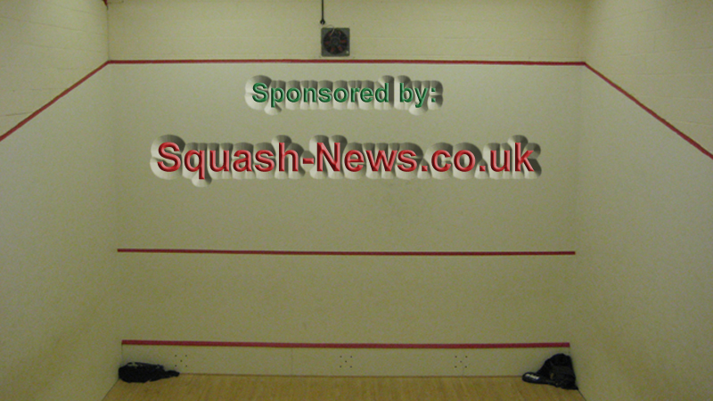
The newly refurbished Court 2. Sponsored by Squash-News.co.uk

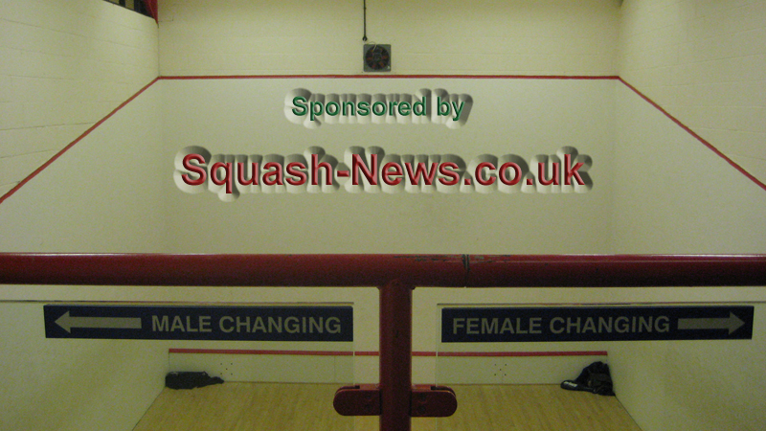
Right Phil. Right for you.

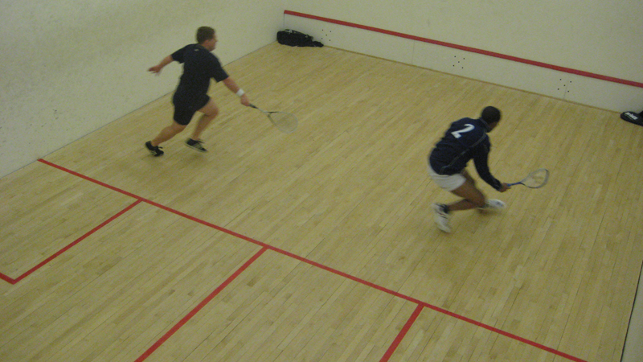
The action gets underway. Little did Dan know what was about to befall him.

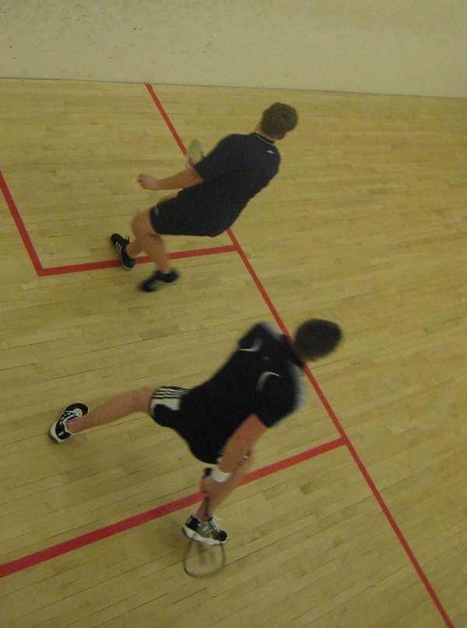
Game 2 was a classic.

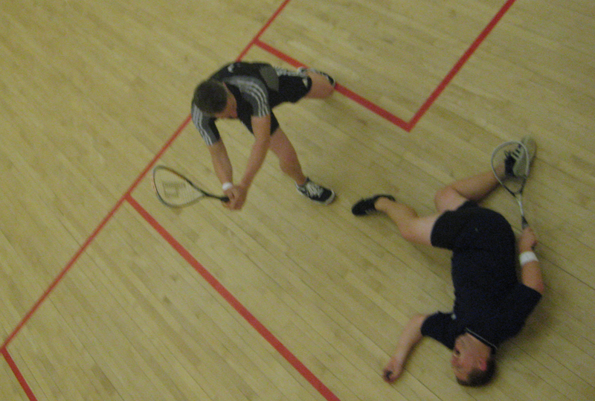
Will Durkin be up on misconduct charges after this ‘off-the-ball’ incident?

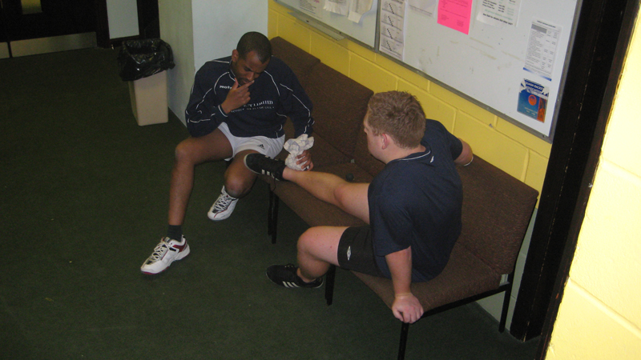
Doctor Phil examines the damage…..What’s the diagnosis?

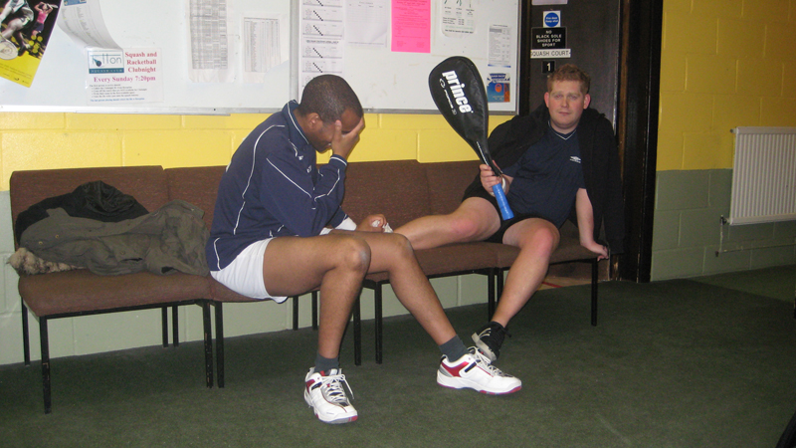
It looks bleak for Pollinger…..

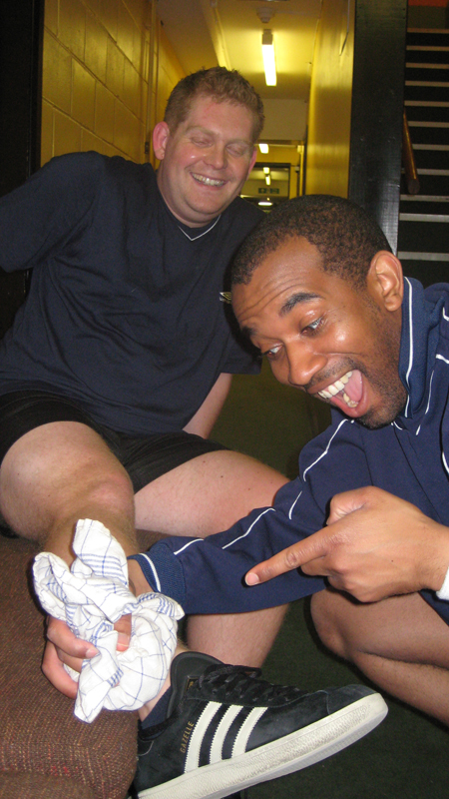
Hold up! It’s all gonna be alright! Brilliant.

This week’s sponsors: The hilarious Kiniki Aero-briefs. ‘The Most Comfortable and Stylish Underwear You’ll Ever Own!’


Keep it locked to Squash News. More insights from the Arena next week.

